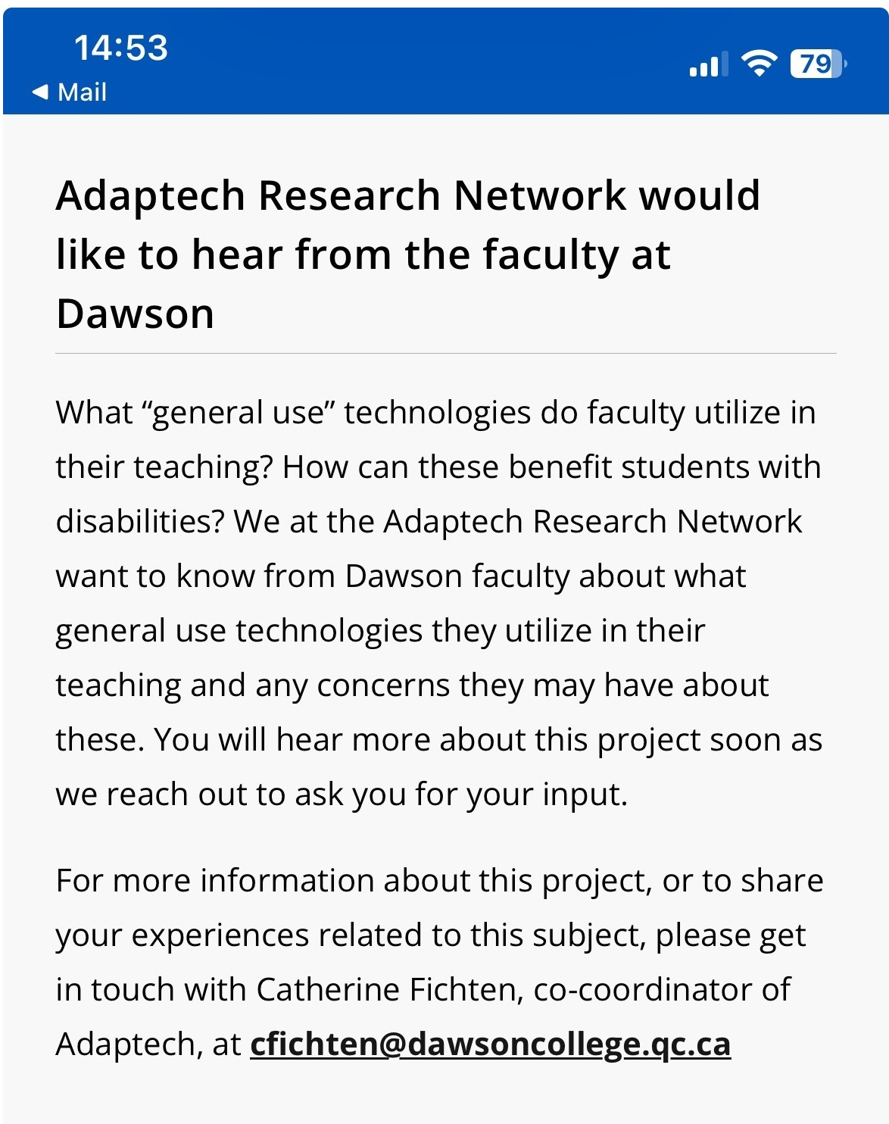
https://can01.safelinks.protection.outlook.com/?url=https%3A%2F%2Fwww.dawsoncollege.qc.ca%2Fnews%2Fd-announcements%2F&data=05%7C02%7Ccatherine.fichten%40mcgill.ca%7C5d7beb17a8de470d79b808dc235f8ebe%7Ccd31967152e74a68afa9fcf8f89f09ea%7C0%7C0%7C638424140511499849%7CUnknown%7CTWFpbGZsb3d8eyJWIjoiMC4wLjAwMDAiLCJQIjoiV2luMzIiLCJBTiI6Ik1haWwiLCJXVCI6Mn0%3D%7C0%7C%7C%7C&sdata=HVIGK0uuVyJyBl6LnZvmkobh8s9COTp%2BnCIAej1SwKM%3D&reserved=0

