Fostering student success in clinical environments - what can clinical educators do?
Author: Cathy Roy Adaptech Research Network May 2024

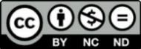

The following tips and suggestions come from an unpublished paper by Cathy Roy, a colleague and teacher in Dawson’s Physiotherapy Technology Program. The full article can be found in the Adaptech toolkit resources. Cathy’s work encompasses integrating the principles of Universal Design for Learning in clinical education. The basic principle of UDL in clinical education puts the clinical educator in the role of designer, considering learner needs in the context of the environment, identifying barriers to learning, and testing and implementing solutions in an iterative cycle that allows not only individual student performance to improve, but benefits all current and future learners by removing identified barriers. UDL goes beyond basic “access” to help educators support student learning through modeling, scaffolding, and fostering learner autonomy where obstacles to student success have been identified. 1 Pages 2 – 4 of this document are intended as a printable, shareable quick-access resource that summarizes various ideas and solutions from the literature structured according to the UDL CAST guidelines.2
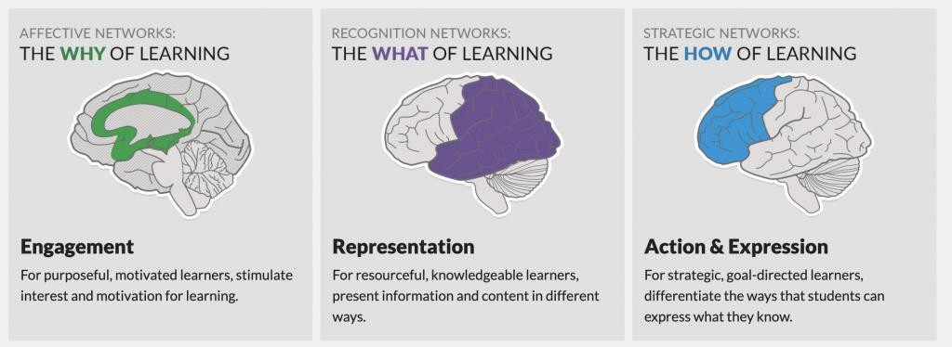

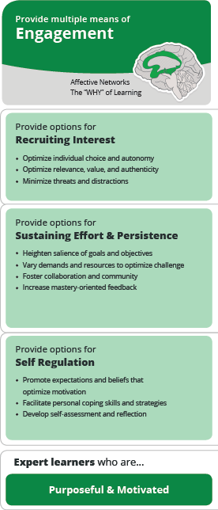

Options for engagement in a clinical setting:

Recruiting interest: FOSTER ENTHUSIASM AND SAFETY
- Model enthusiasm for the site/context 3
- Provide adaptable hours/shift patterns 4
- Match clinical site to student preferences and geographic locationf 5
- Organize site visits & provide information work tasks prior to start date 6–8
- Provide a quiet location to read and write5
- Provide unrestricted access to a resource room for all students 8
- Close the curtain when working with patients to minimize distractions5

Sustaining effort and persistence: BUILD CONFIDENCE
- Create a welcoming environment with explicit value placed on diversity3
- Use engaging orientation activities including icebreakers & gamification 7
- Provide frequent, specific & actionable feedback 3,6
- Provide clear and transparent learning objectives3,7
- Review objectives early, using visual supports (e.g. concept map) 3,7
- Organize student mentorship 4,6,7
- Foster spirit of community & support5,6
- Use virtual patients or off-site sims for extra skills practice 10

Self-regulation: BUILD AUTONOMY
- Schedule both physical and mental breaks5
- Allow flexible scheduling to support mentorship as needed 8
- Scaffold self-reflection & self-assessment 3
- Model positive outlook & support development of coping mechanisms, 6
- Support disclosure as needed and guide students to appropriate help 4

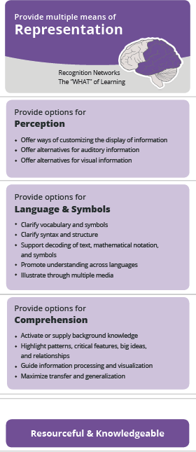

Options for representation in a clinical setting:

Perception: SUPPORT PROCESSING OF INFORMATION
- Allow screen readers, Scribe pens & text magnification apps5
- Allow digital access to documentation off-site5
- Provide video/audio versions of resources with captions & transcript 9
- Provide site maps & organizational chart of personnel with pictures8
- Provide hard copy and digital versions of reading materials8

Language & symbols: SUPPORT DECODING OF INFORMATION
- Allow recording of interactions & discussions (with consent)5
- Provide paper & electronic lexicons for institutional/disciplinary language 8
- Use mnemonics to support memorization of procedures and skills e.g. ISBAR 8
- Allow digital dictionaries & translation tools for language barriers5
- Suggest students carry notepad or index cards5

Comprehension: SUPPORT DEEP UNDERSTANDING & REASONING
- Use graphic organizers to structure information e.g:
  - cue cards, mind map software, visual flow charts for procedures4 8
- Provide case examples and models for application of information3 8
- Use peer modeling & feedback: work independently, then compare 5
- Highlight critical features of a procedure, surgery, policy 8
- Teach in a systematic way, e.g. from head to toe, or inside to outside 8
- Use similar assessment formats from classroom to clinic 9
- Use verbal comprehension tool “RAP” to support reading comprehension:
- Read a document, Ask meaning (2 key details), Paraphrase 9
- Suggest students create “crib notes” to prompt quick decision-making 5
- Allow students to record difficult procedures, encourage students to find/watch videos of medical interventions in their field to activate background knowledge 5

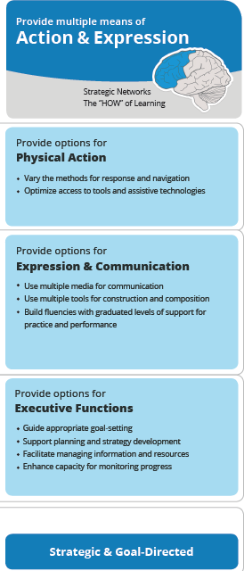
Options for action & expression in a clinical setting:

Physical action: ALLOW VARIED MEANS OF INTERACTING
- Allow use of tech while ensuring patient confidentiality5
  - digital pens
  - read and write, Kurzweil, or Word Q software
  - noise cancelling headphones for concentration in charting
  - mobile technology for dictation and recording

Expression: ALLOW TOOLS TO SUPPORT COMMUNICATING
- Allow writing technologies to support charting and other documentation, e.g.:
  - Medical spell check and dictionary software or devices 8
  - Dragon medical dictation software 8
  - Antidote software for grammar & translation 5
  - Word prediction feature 5

Executive function: SUPPORT DEVELOPMENT OF SELF-REGULATION
- Place clocks on the walls in main workspaces to support time management8
- Scaffold student goal setting 6
- Encourage use of note-taking and to-do apps 5 9
- Allow multiple media for clinical reflections (e.g. audio/video) 5
- Support autonomous scheduling & time management using apps/calendars 7,9
- Negotiable deadlines (e.g. collaboratively decided) and “negotiated time-outs” 4
- Use of checklists/flowcharts for repeated or procedural tasks 5,8

For more information about the toolkit, please see the full article “Turning Two Ships in Tandem: Applying the UDL Framework in Clinical Settings”

References
- LaRocco DJ, Fanelli LL. Universal Design for Learning for Clinical Educators: Design Thinking in Clinical Settings. In: Fovet F, ed. Advances in Educational Technologies and Instructional Design. IGI Global; 2021:389-411. doi:10.4018/978-1-7998-7106- 4.ch020
- CAST. Universal Design for Learning Guidelines version 2.2. Published online 2018. http://udlguidelines.cast.org
- Murphy L, Panczykowski H, Fleury L, Sudano B. Implementation of Universal Design for Learning in Occupational Therapy Education. Occupational Therapy in Health Care. 2020;34(4):291-306. doi:10.1080/07380577.2020.1780663
- Tee S, Cowen M. Supporting students with disabilities – Promoting understanding amongst mentors in practice. Nurse Education in Practice. 2012;12(1):6-10. doi:10.1016/j.nepr.2011.03.020
- Fichten, C., Havel, A., Wileman, S., Jorgensen, M. Students with Disabilities in Clinical Internships: Perspectives of College Faculty, Accessibility Advisors, and Students. Adaptech Research Network, Dawson College, Montreal, Canada. Published online 2024.
- Brown K, James C, MacKenzie L. The Practice Placement Education Experience: An Australian Pilot Study Exploring the Perspectives of Health Professional Students with a Disability. British Journal of Occupational Therapy. 2006;69(1):31-37. doi:10.1177/030802260606900106
- Heelan A, Halligan P, Quirke M. Universal Design for Learning and Its Application to Clinical Placements in Health Science Courses (Practice Brief). Journal of Postsecondary Education and Disability. 2015;28(4):469-479.
- Pace K, Pace A, Martyn K, Halligan P, Gee N. Universal Design for Learning to support nursing students: Experiences in the Field. Published online May 1, 2019:1-14.
- Harris C. Reasonable adjustments for everyone: Exploring a paradigm change for nurse educators. Nurse Education in Practice. 2018;33:178-180. doi:10.1016/j.nepr.2018.08.009

