Fostering student success in clinical environments - what can teachers do?
Author: Cathy Roy
Adaptech Research Network
May 2024

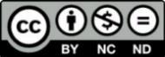
The following tips and suggestions come from an unpublished paper by Cathy Roy, a colleague and teacher in Dawson’s Physiotherapy Technology Program. Cathy’s work encompasses integrating the principles of Universal Design for Learning in clinical education. Here are some practical and helpful approaches to inclusion in clinical education:

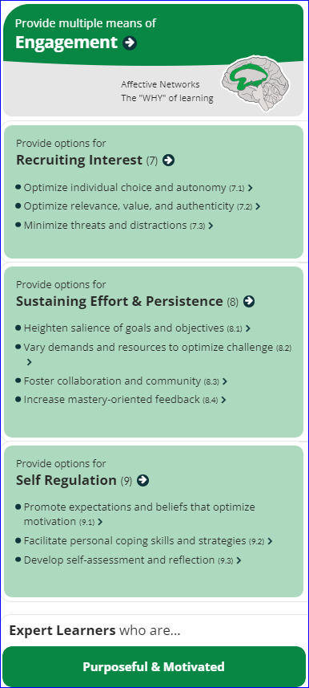
Options for engagement in a clinical setting:
Recruiting interest:
- Displaying enthusiasm for the site/context (Murphy et al., 2020)
- Providing adaptable hours/shift patterns (Tee & Cowen, 2012)
- Matching clinical site to student preferences and geographic location. (Fichten et al.)
- Organizing site visits and providing information on the nature of work tasks prior to start date (Brown et al., 2006; Heelan et al., 2015; Pace et al., 2019)
- Providing a quiet location to read and write
- Providing unrestricted access to a resource room for all students (Pace et al., 2019)
- Closing the curtain when working with patients to minimize distractions (Fichten et al.)
Sustaining effort and persistence:
- Welcoming environment with explicit value placed on diversity
- Engaging orientation activities including icebreakers or gamifying information (Heelan et al., 2015)
- Frequent, specific & actionable feedback (Brown et al., 2006; Murphy et al., 2020)
- Transparent learning objectives, reviewed early using visual supports (e.g. concept map) (Heelan et al., 2015; Murphy et al., 2020)
- Student mentorship (Brown et al., 2006; Heelan et al., 2015; Tee & Cowen, 2012)
- Environment (face to face or online) that encourages peer interaction (across or within sites/intra or inter-disciplinary) to create spirit of community & support (Fichten et al., Brown et al., 2006)

Self-regulation
- Scheduling breaks, both physical and mental (Fichten et al.)
- Flexibility to schedule support or mentorship appointments as needed (Pace et al., 2019)
- Scaffolding self-reflection/self-assessment (Murphy et al., 2020)
- Modeling a positive outlook & supporting development of personal coping mechanisms, (Brown et al., 2006)
- Supporting disclosure as needed and guiding student to appropriate help (Tee & Cowen, 2012)

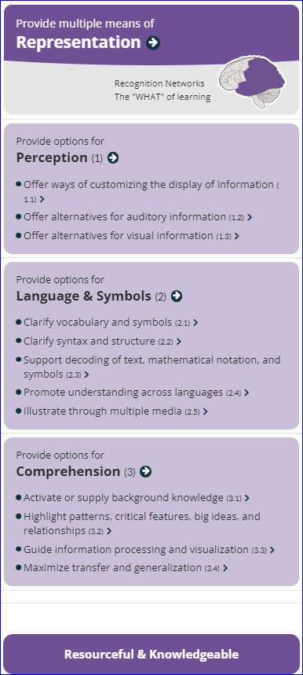
Options for representation in a clinical setting:
Perception
- Screen reading, C-pen/scribe pen & apps that allow zoom/magnification of text (Fichten et al., 2024)
- Access to documentation off-site digitally (Fichten et al.)
- Video/audio resources (e.g. policies/procedures) with captions & transcript (Harris, 2018)
- Site maps & organizational chart of personnel with pictures (Pace et al., 2019)
- Hard copy and digital versions of reading materials (Pace et al., 2019)
- Clocks on the walls in each room (Pace et al., 2019)
Language & symbols
- Allow recording of interactions, discussions, or seminars (need signed consent) (Fichten et al., 2024)
- Provide paper and electronic supports/lexicons for institutional/disciplinary language specifics (Pace et al., 2019)
- Mnemonics for memorizing different procedures and skills e.g. ISBAR (Pace et al., 2019)
- Digital dictionaries & translation tools for language barriers (Fichten et al., 2024)
- Carry notepad or index cards (Fichten et al., 2024)
Comprehension
- Use graphic organizers to structure information e.g. cue cards, mind map software, step by step flow charts for procedures, visual flow charts (Tee and Cowen, 2012; Pace et al., 2019)
- Provide examples and application of information, such as cases for prioritization (Pace et al, 2019, Murphy et al., 2020)
- Peer learning: students create lists of goals for clients and compare (Fichten et al., 2024)
- Highlight critical features of a procedure, surgery, policy (Pace et al., 2019)
- Teach in a systematic way, e.g. from head to toe, or inside to outside (Pace et al., 2019)
- Use similar assessment formats from classroom to clinic (Hua et al., 2014).
- Use verbal comprehension tool “RAP” to support reading comprehension: Read a document, Ask meaning (2 key details), and then Paraphrase (Hua et al., 2014).
- Suggest students create “crib notes” to prompt quick decision-making (Fichten et al, 2024)
- Allow students to record difficult procedures, encourage students to find/watch videos of medical interventions in their field to activate background knowledge (Fichten et al, 2024)
Options for action & expression in a clinical setting:
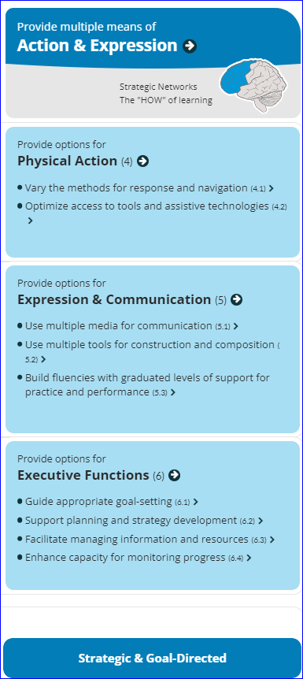
Physical action (Fichten et al., 2024)
- Use of digital pens
- Read and write, Kurzweil, or Word Q software
- Noise cancelling headphones for concentration.
- Mobile technology for dictation and recording (while ensuring patient confidentiality).
Expression & communication
- Medical spell check and dictionary software or devices (Pace et al., 2019)
- Dragon medical dictation software (Pace et al., 2019)
- Antidote software for grammar & translation (Fichten et al., 2024)
- Word prediction feature (Fichten et al., 2024)
- Use of virtual patients for extra non-technical skills practice (Peddle et al., 2020)
- Practice of critical skills in off-site simulations (Heelan et al., 2015)
Executive function
- Guided goal setting (Brown et al., 2006)
- Encourage use of note-taking and to-do apps (Fichten et al., 2024; Harris, 2018)
- Multiple media for clinical reflections (e.g. audio/video)
- Support autonomous scheduling & time management using apps/physical calendars completed by the student/automated reminders (Harris, 2018; Heelan et al., 2015)
- Negotiable deadlines (e.g. collaboratively decided) and “negotiated time-outs” (Tee & Cowen, 2012)
- Use of checklists/flowcharts for repeated or procedural tasks (Fichten et al., 2024; Pace et al., 2019)

References
Brown, K., James, C., & MacKenzie, L. (2006). The Practice Placement Education Experience: An Australian Pilot Study Exploring the Perspectives of Health Professional Students with a Disability. British Journal of Occupational Therapy, 69(1), 31–37. https://doi.org/10.1177/030802260606900106
Fichten, C., Havel, A., Wileman, S., & Jorgensen, M. (2024) Students with Disabilities in Clinical Internships: Perspectives of College Faculty, Accessibility Advisors, and Students. Adaptech Research Network, Dawson College, Montreal, Canada.
Harris, C. (2018). Reasonable adjustments for everyone: Exploring a paradigm change for nurse educators. Nurse Education in Practice, 33, 178–180. https://doi.org/10.1016/j.nepr.2018.08.009
Heelan, A., Halligan, P., & Quirke, M. (2015). Universal Design for Learning and Its Application to Clinical Placements in Health Science Courses (Practice Brief). Journal of Postsecondary Education and Disability, 28(4), 469–479.
Murphy, L., Panczykowski, H., Fleury, L., & Sudano, B. (2020). Implementation of Universal Design for Learning in Occupational Therapy Education. Occupational Therapy in Health Care, 34(4), 291–306. https://doi.org/10.1080/07380577.2020.1780663
Pace, K., Pace, A., Martyn, K., Halligan, P., & Gee, N. (2019). Universal Design for Learning to support nursing students: Experiences in the Field. 1–14.
Peddle, M., Bearman, M., McKenna, L., & Nestel, D. (2020). “Getting it wrong to get it right”: Faculty perspectives of learning non-technical skills via virtual patient interactions. Nurse Education Today, 88, 104381. https://doi.org/10.1016/j.nedt.2020.104381
Tee, S., & Cowen, M. (2012). Supporting students with disabilities – Promoting understanding amongst mentors in practice. Nurse Education in Practice, 12(1), 6–10. https://doi.org/10.1016/j.nepr.2011.03.020

