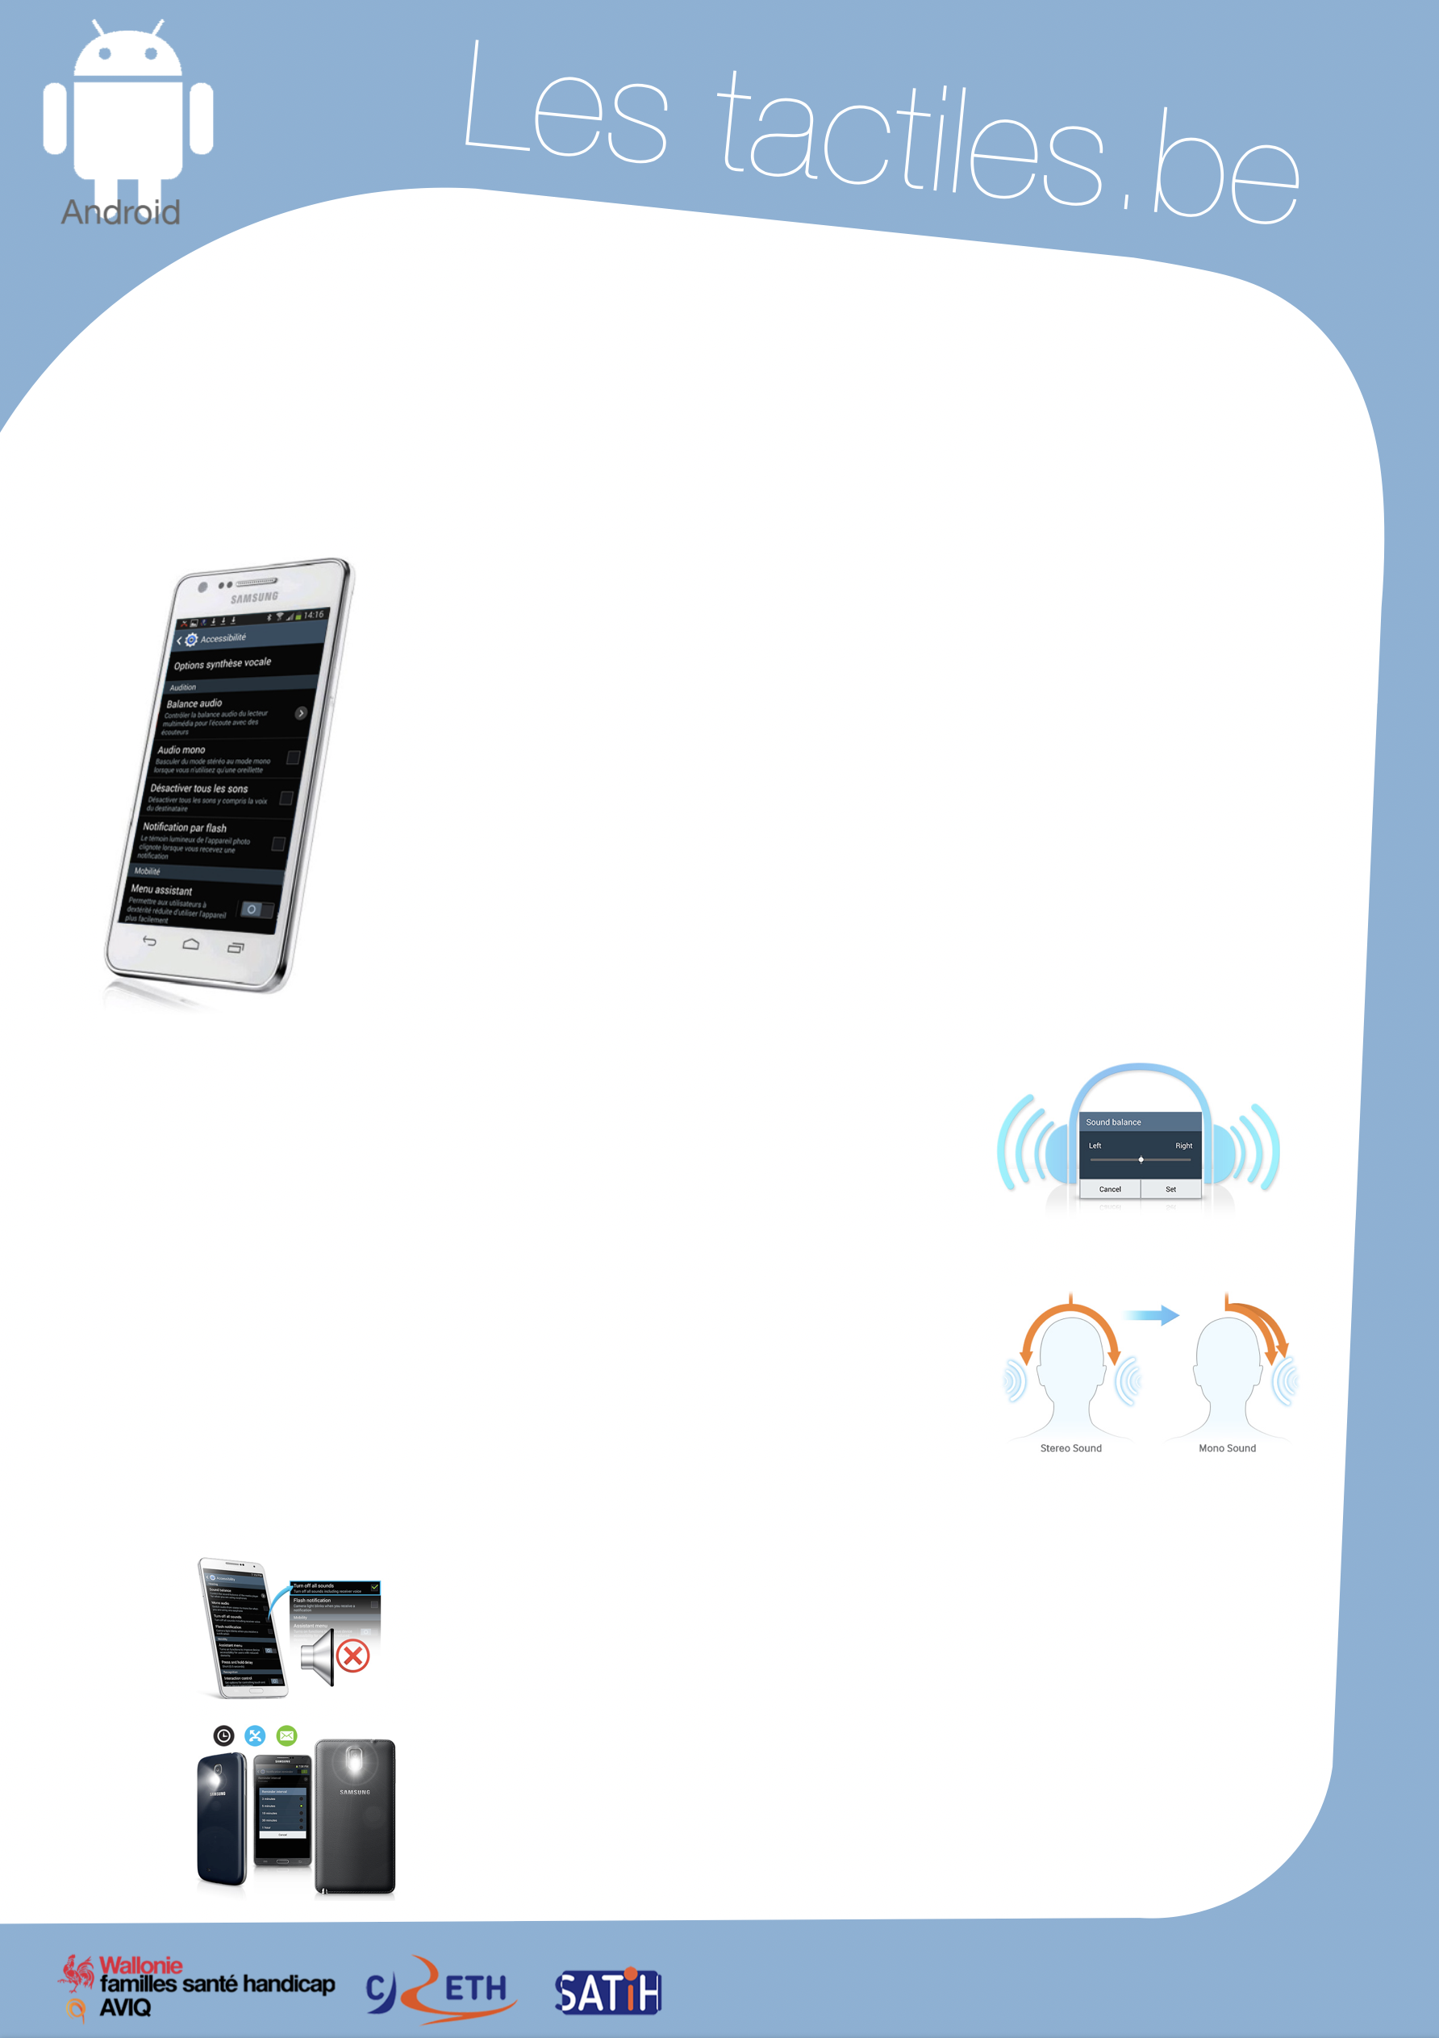

Link for Les tactiles.be

Image: A picture of Android’s mascot.

The accessibility tags of your tablets and smartphones

Android Settings for the Deaf and Hearing Impaired

Image: A picture of an Android smartphone on the accessibility menu.

The settings that Android offers for people with hearing impairment are grouped into four subgroups:
- Audio balance
- Mono audio
- Deactivate all sounds
- Flash notification

You can find these settings in:
Settings/My Device/Accessibility/Audio settings

Audio balance is just left/right balance of the audio device. It allows you to personalize the balance for better listening comfort.

Image: A picture of the menu screen for audio balance.
Mono audio merges the stereo sound channels into a single mono channel.

Image: A picture of the differences between stereo sound and mono sound.

Deactivating all sounds makes your smartphone mute. You will not hear anything, not even the voice of callers.

Image: A picture of the sound muted on an Android smartphone.
Flash notification is a feature that blinks the flash of the camera to indicate that you have received a notification. To stop the blinking, you just turn the device over.

Image: A picture of the flash notification on a Samsung smartphone.

Image: The logos of “Wallonie familles santé handicap AVIQ”, “CRETH” and “SATIH”.

