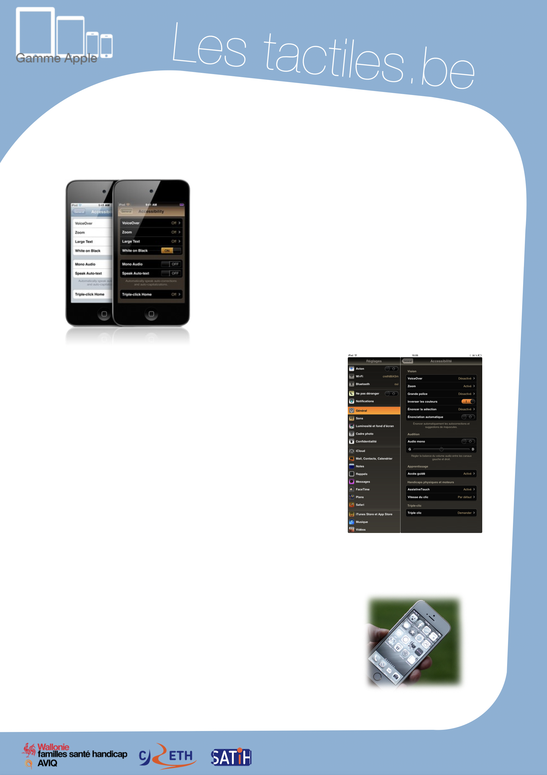

Link for Les tactiles.be

Image: A picture of Apple devices.

The accessibility tags of your tablets and smartphones

Inverting the colours of the interface

Image: A picture of the accessibility menu on iPhone.

“Invert colours” option

This accessibility feature allows you to toggle the display in negative colours for any application.

The “invert colours” feature can be activated through the accessibility menu from the Settings application.

Settings/General/Accessibility/Invert colours

Inverting colours work on all screens: Home screen, lock screen, Spotlight, and applications bought from the App Store.

Since iOS 6, this feature works perfectly with VoiceOver.

To improve readability, you can modify the intensity of the contrast through the Brightness setting.

Image: A picture of the accessibility menu from an Apple device.

Brightness Settings and Wallpaper

For iOS 8, the feature to invert colours will have additional display accommodations such as grayscale or inverted grayscale.

This will allow you to display the screen without colour, and to help certain people with visual impairment feel more comfortable.

Image: A picture of an iPhone with a grayscale display.

Image: The logos of “Wallonie familles santé handicap AVIQ”, “CRETH” and “SATIH”.

