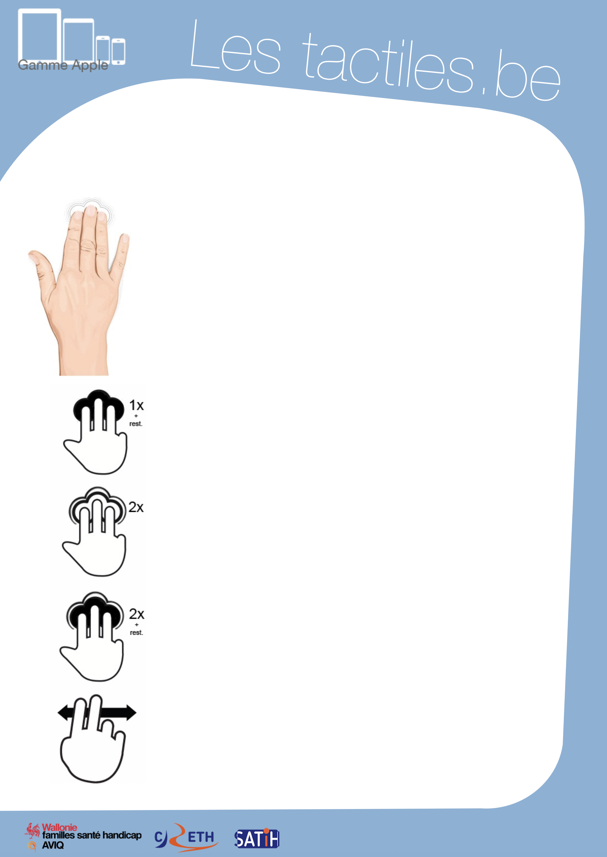

Link for Les tactiles.be

Image: A picture of Apple devices.

The accessibility tags of your tablets and smartphones

Navigation Gestures with ZOOM

Image: A picture of a hand doing a three-finger gesture.
To begin, here is a small lexicon
of important gestures:

Image: A picture of a hand doing a three-finger touch gesture with the text “1x + hold.”

Touch once with and leaving three fingers and hold

Action of touching the screen your finger against it.

Image: A picture of a hand doing a three-finger touch gesture with the text “2x.”

Touch twice with quickly twice and three fingers
Action of touching the screen quickly twice and withdraw your fingers afterward.

Image: A picture of a hand doing a three-finger touch gesture with the text “2x + hold.”

Touch twice with three fingers and hold

Action of touching the screen twice and leaving your finger against it on the second touch.

Image: A picture of a hand doing a swiping motion.
Swipe two fingers

Action of quickly swiping the screen from
one side to the other.
Here is a summary of gestures for Zoom:

3-finger gestures Actions

Touch once and hold Allows you to move around on the magnified page.
Touch twice Activate or deactivate the magnification.
Touch twice and hold Allows adjustment and personalization of the zoom
size by moving towards the top of the screen
(zoom up) or moving towards the bottom of the screen (zoom out).

2-finger gestures Actions

Swipe left/right Move from one page to the other.

1-finger gestures Actions

Swipe left/right Move from one page to the other (just like the two- finger gesture.)
Trick
In ZOOM mode, by placing and holding one finger on one of the corners or side of the screen, the screen moves towards the chosen direction.

For iOS 8 that will be released this fall, Zoom has been entirely redesigned.

Find all of the new features of magnification on the “Utilisation de l’accessibilité ZOOM” file.

