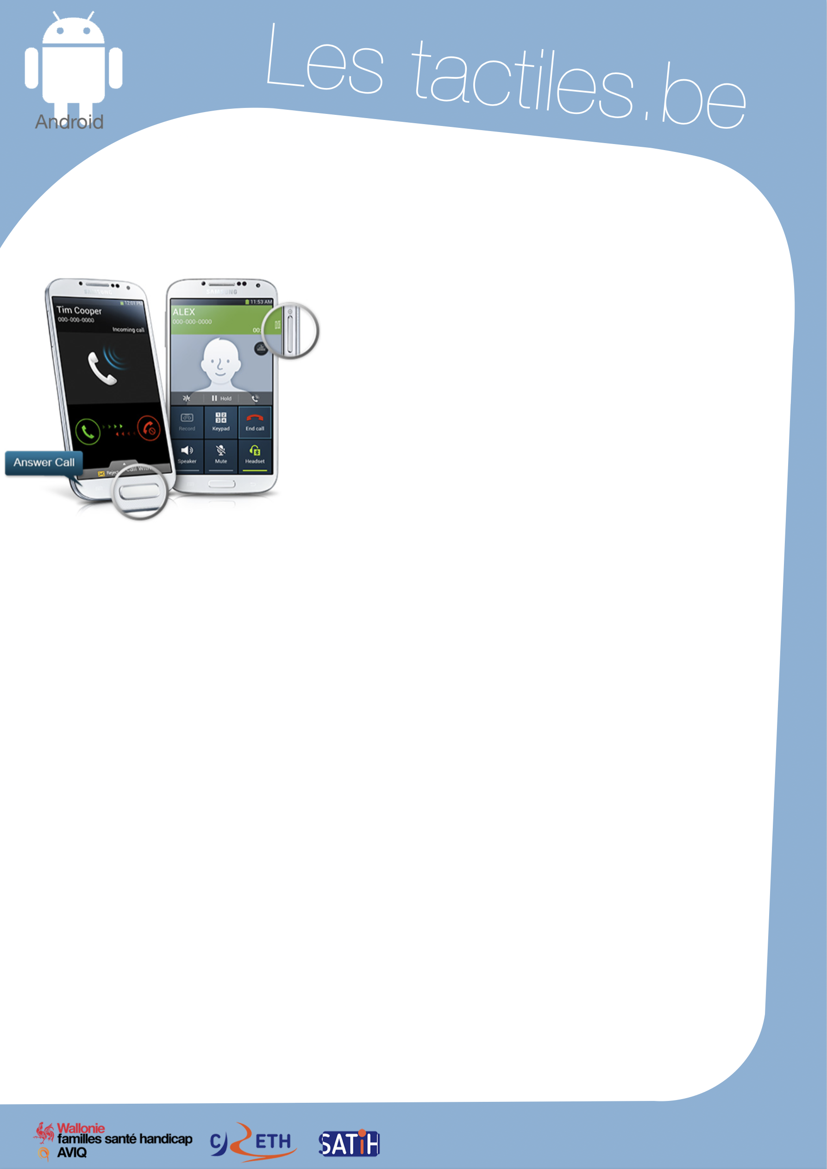

Link for Les tactiles.be

Image: A picture of Android’s mascot.

The accessibility tags of your tablets and smartphones

Simplify Answering and Ending Phone Calls

Image: A picture of the phone call menu on Android.

Description

The option “/End Call” allows you to personalize and simplify the way you pick up or hang up the telephone. The setting can be done very simply and intuitively.

How to access it
Application/Settings/My Device/Accessibility/Start or End Call

How does it work

- The Home button (the physical button on the front of the device) allows you to answer phone calls: once the option is activated, you can answer phone calls with the Home button.
- The Power key to end phone calls: with the option activated, you can end phone calls by pressing the physical button on the right side of your device, which otherwise serves to light up or turn off the device. Rest assured, the device will not turn off if you are in a call.

Info
You can also use other applications with your voice thanks to voice commands (Alarm, Music, Camera, etc…).

Image: The logos of “AWIPH”, “CRETH” and “SATIH”.

