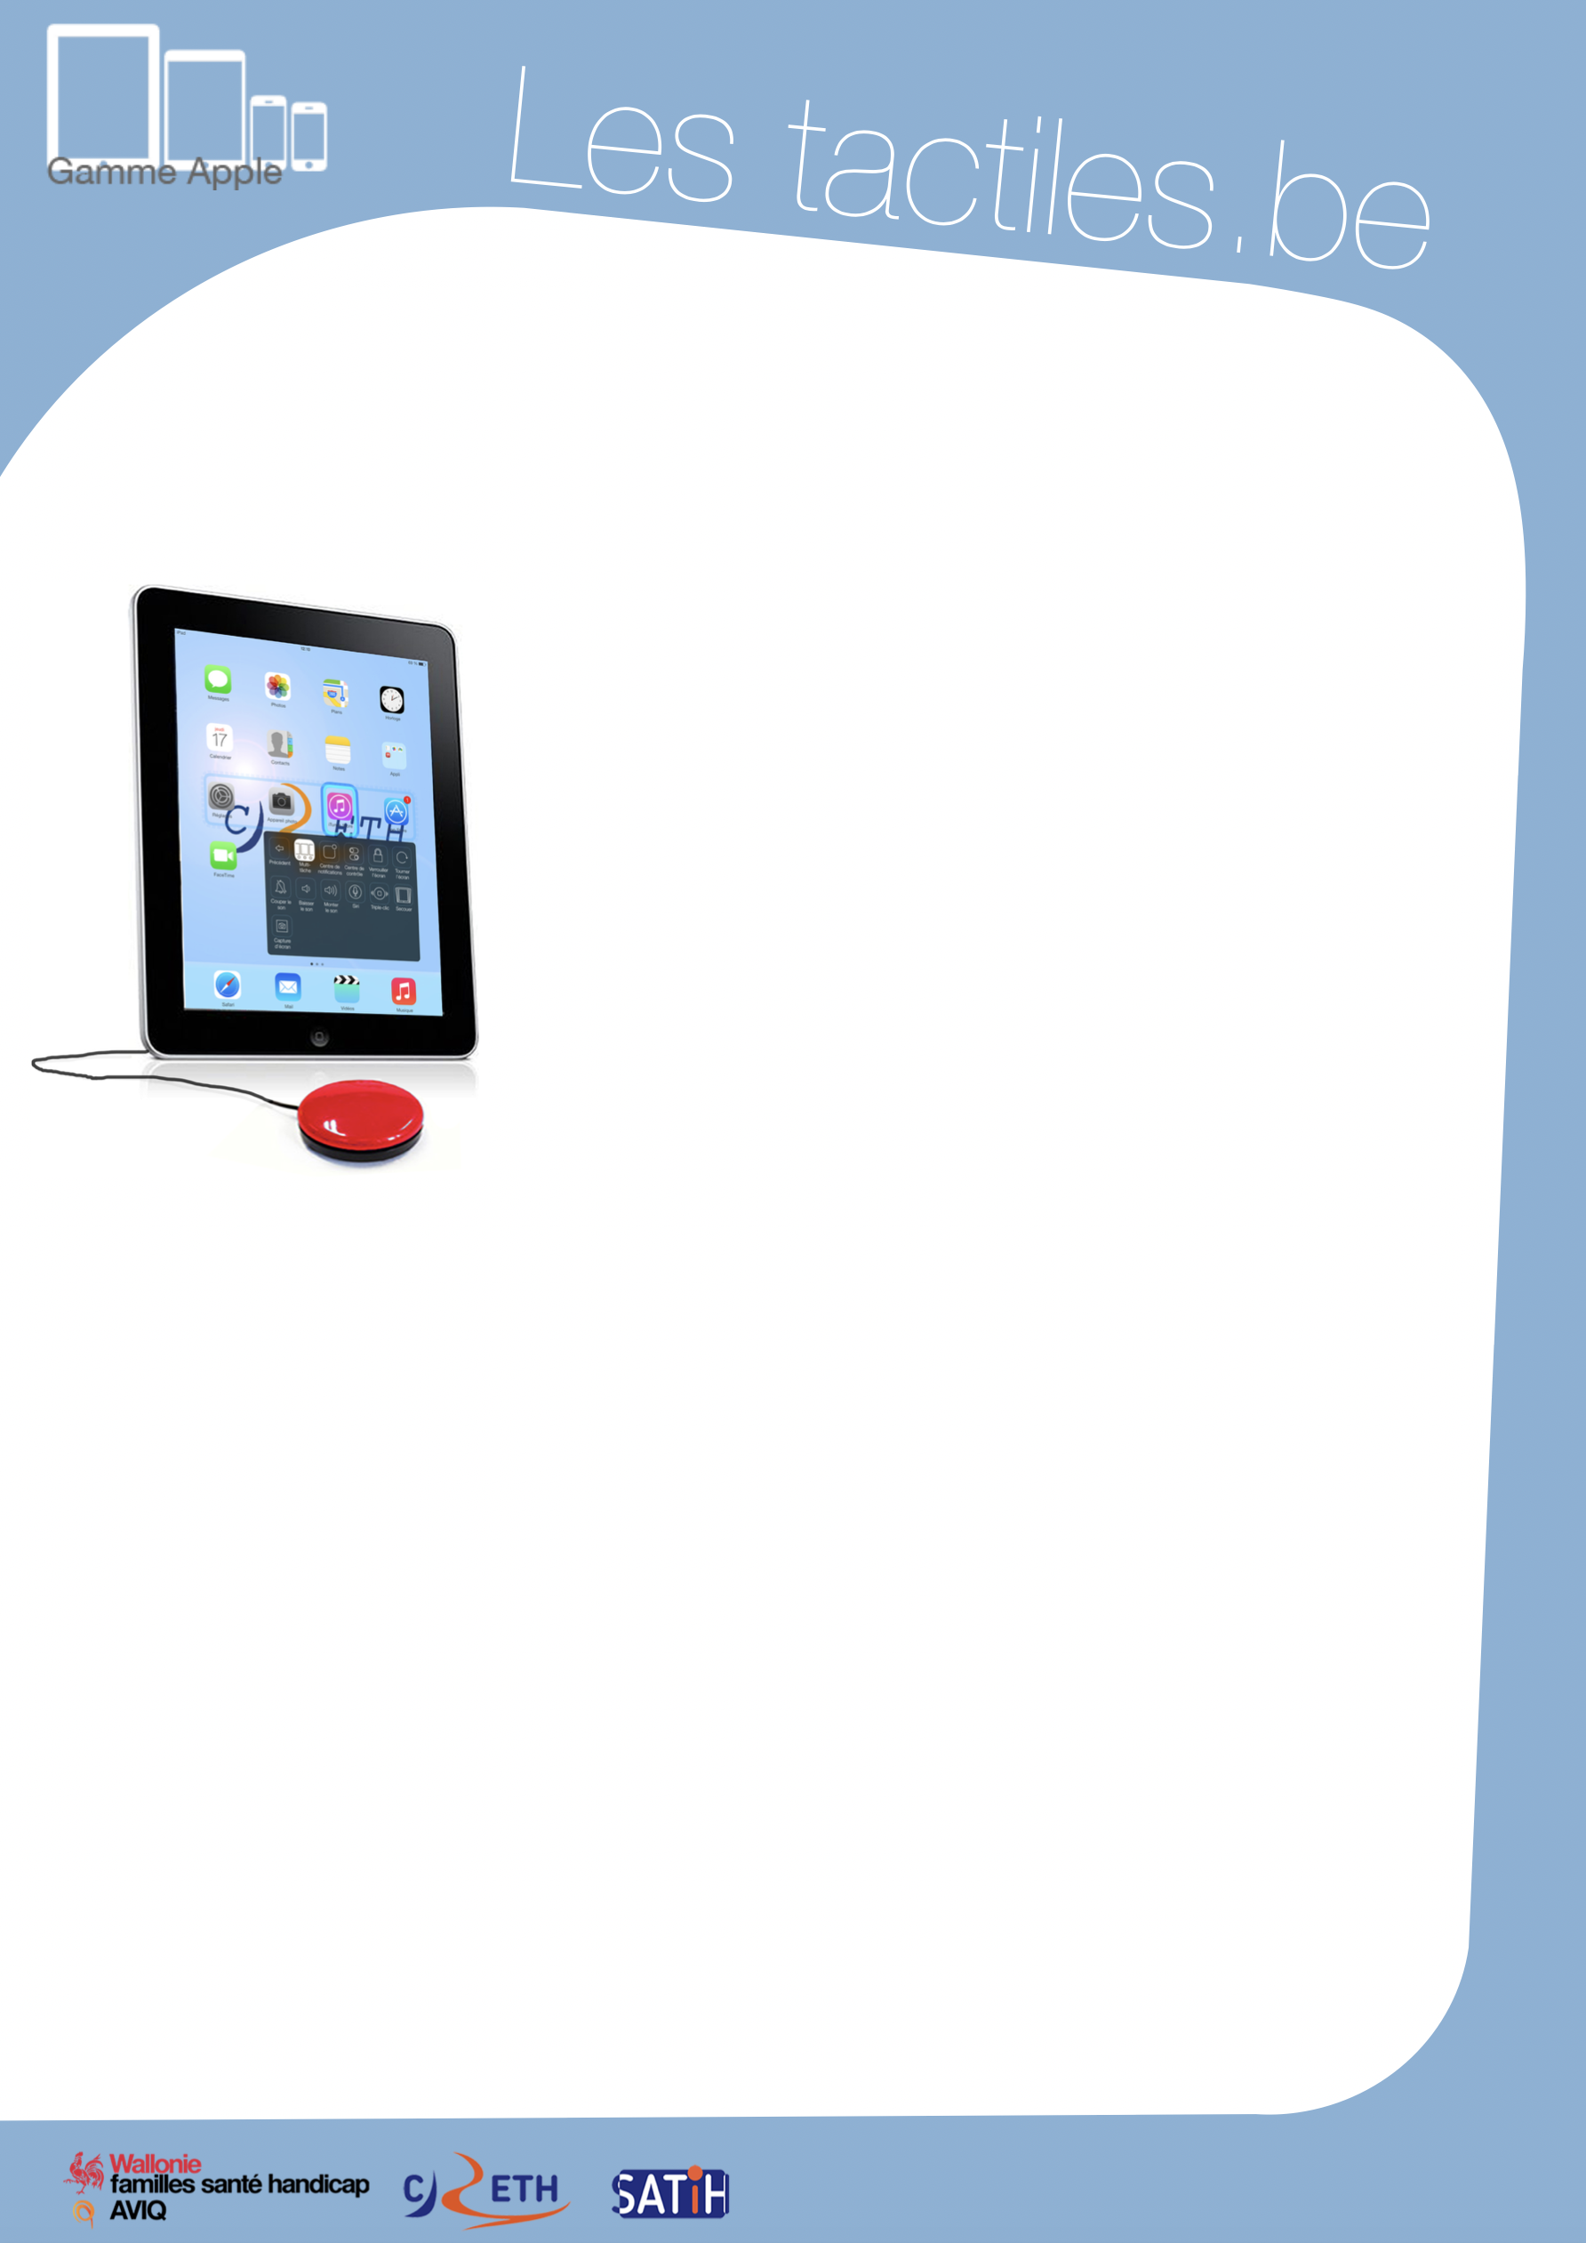

Link for Les tactiles.be

Image: A picture of Apple devices.

The accessibility tags of your tablets and smartphones

Navigate by Swiping with

Switch Control

Image: A picture of an iPad and a switch control.

What is Switch Control?

It is a new accessibility feature that was introduced on iOS 7 which allows you to navigate by scanning:

A selection rectangle moves automatically from one group of applications to another or from one function/button to another while waiting for you to select by tapping anywhere on the screen with either Bluetooth switches or with movement of the head in order to confirm your choice.

How to access it
Settings/General/Accessibility/Switch Control

Settings
The settings menu will allow you to customize features of the switch control:
- Choose the number of buttons
- Duration of the analysis, number of loops and pauses
- Holding and repetition of a button press
- Cursor speed
- Auditory effects and vocal information
- Colour and size of the cursor, etc.

In summary, the settings are very comprehensive and can be personalized for your navigation.

Image: The logos of “Wallonie familles santé handicap AVIQ”, “CRETH” and “SATIH”.

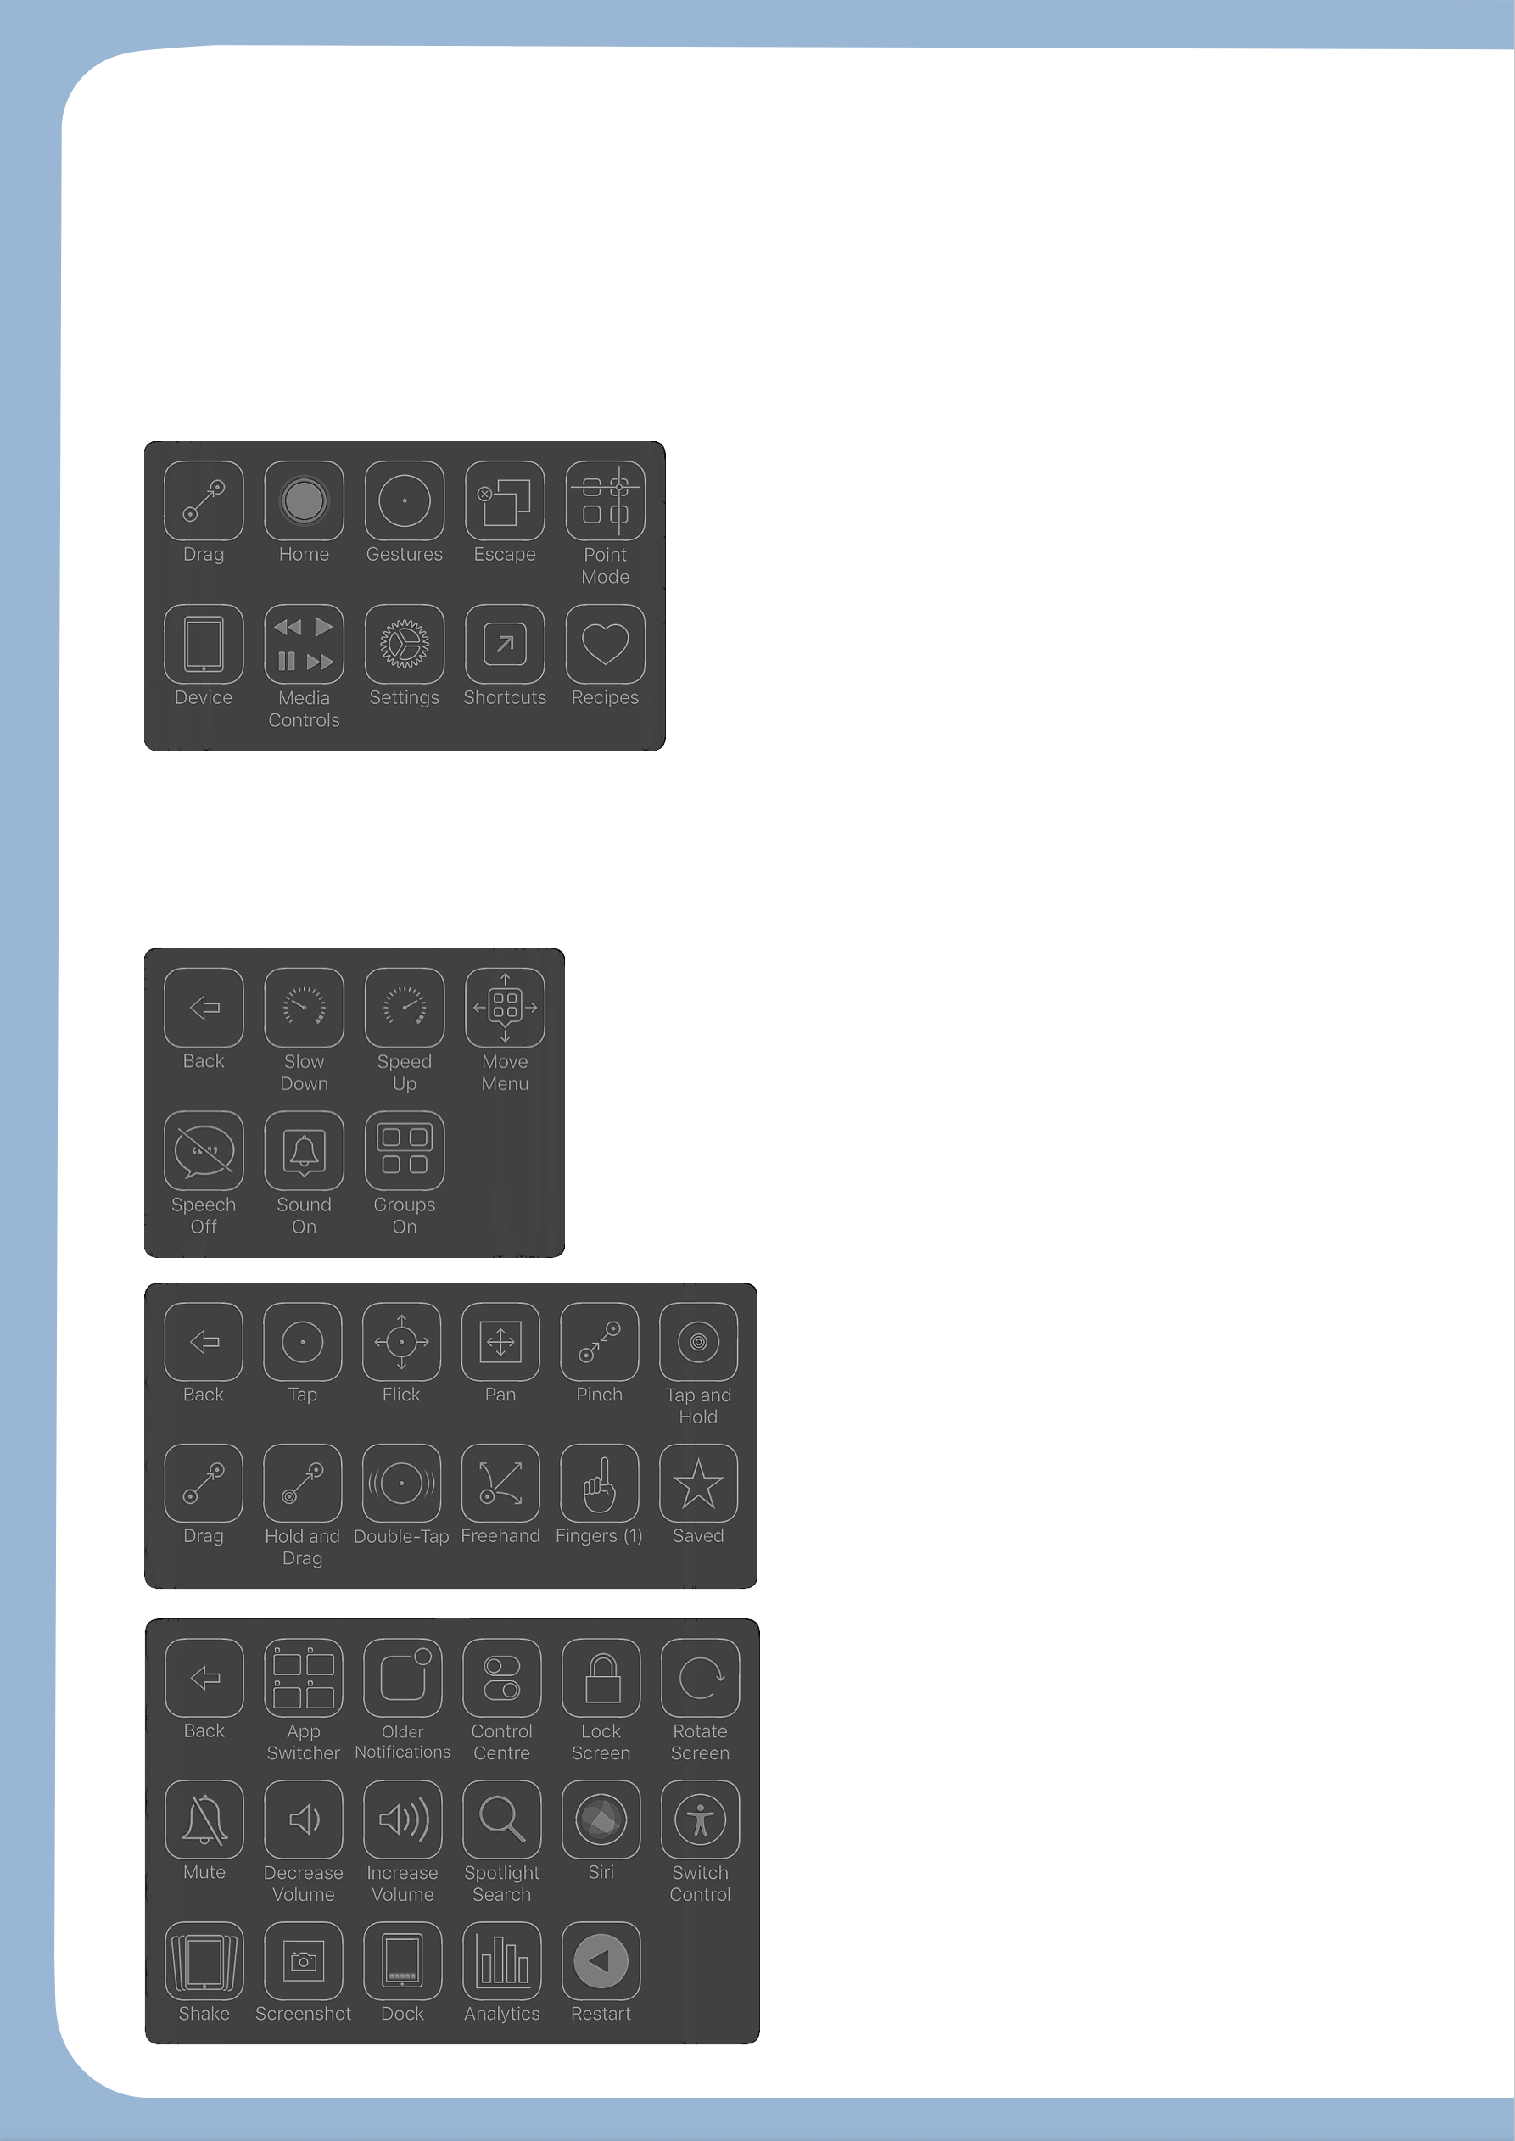
In Practice

Once the switch control is activated, you have to react to avoid having to wait for the next loop. Once the application is selected and confirmed by an input or button press, a new screen will pop up to show new options:

The first ones correspond to a simple touch which allows you to open to application you selected.

Image: A picture of a switch control menu.
Tap: touch action.
Scroll: previous page, next page, go back.
Home: corresponds to a button press of the Home button.
Gestures: suggest a series of 12 (modifiable) common gestures.
Device: suggest a series of 13 settings, such as volume, multitask, Siri, screen capture, rotation, etc.
Settings: suggest 9 settings specifically for the switch control.

Here are some of the numerous menus from “Switch Control.”

Image: A picture of the main switch control menu on iOS.

Image: A picture of the gestures menu for the switch control on iOS.

Image: A picture of the device menu for the switch control on iOS.

