Welcome to this short video on how to use the Dictate tool in Microsoft Word and some other Office 365 software.

The Dictate tool will type as you speak, giving you a quick way to get your thoughts out without typing.
- To use the Dictate tool in Microsoft Word first locate the Dictate icon 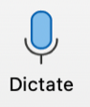 near the top right of your Home toolbar.
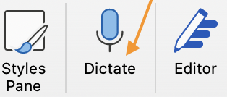
- Select the place in your Word document where you want to add text.
- Click on the Dictate icon. Wait for the Dictate button to turn on and start listening. There might be a delay between activating the dictate feature and the beginning of the dictation.
- Start speaking to see text appear on the screen. Add text here:
- To stop or pause, click on the microphone. Or say – Pause Dictation or Stop Dictation. There might also be a delay between saying your command to Pause or Stop and the actual ending of the Dictation.
- Keep in mind that dictation is often not perfect, and you will need to proofread what you have dictated.
- Click on the gear icon for settings. You can select the language (choice of 49 languages), and the microphone source, test your microphone input level, and choose to enable auto punctuation or filter sensitive phrases.

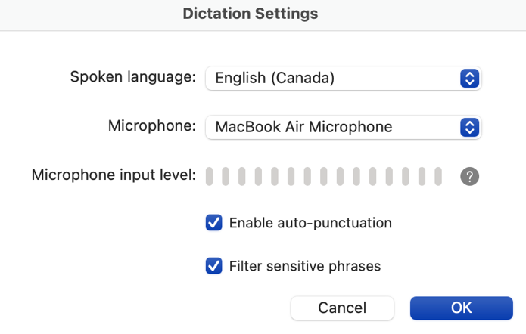

- For further Help click on the ‘?’ in the Dictate box and this will provide you with:
a. A review of How to Use the Dictate tool.
b. Voice Commands you can use for Punctuation, Editing, Navigation, etcetera. Plus, more information and troubleshooting tips.
- The Dictate tool is available in other Microsoft software such as Outlook, PowerPoint, and Excel.
- You may be prompted to set up your microphone on your first attempt to use it.

Thank you for viewing this short video on using the Dictate tool in Microsoft Word.

Roberta Thomson, Adaptech Research Network
Funding: Entente Canada-Québec (ECQ)

