How to work with Google Docs – Online Document Editor
Welcome to this short video on using Google Docs which covers permissions for sharing, making changes anonymously, viewing the version history for the Doc and restoring changes.
Sharing a Google Doc: There are several ways to share a Google Doc.

Share a Document with specific people:
- Open your Google Drive, find the Google Doc you want to share and click on the three dots 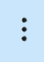 at the far right.
This will open a text box showing several options you have. Click on Share and this opens a choice to Share or Copy Link.
If you choose Copy Link first, you will get a link to share but without knowing what kind of access the receiver is granted.
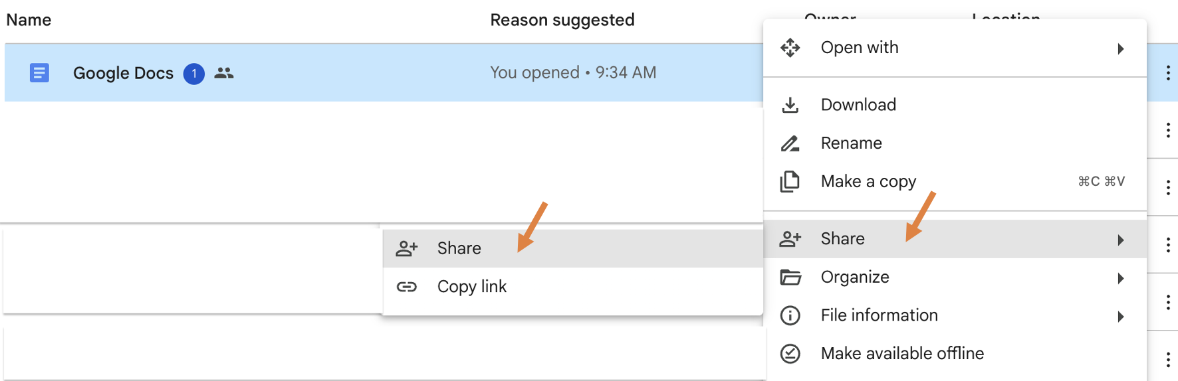

Clicking on Share will open a box where you can input the email address of the person(s) you want to Share the Doc with. Currently, the
General access is ‘Restricted’ which means that only people who have been given access can open the Doc with the link.
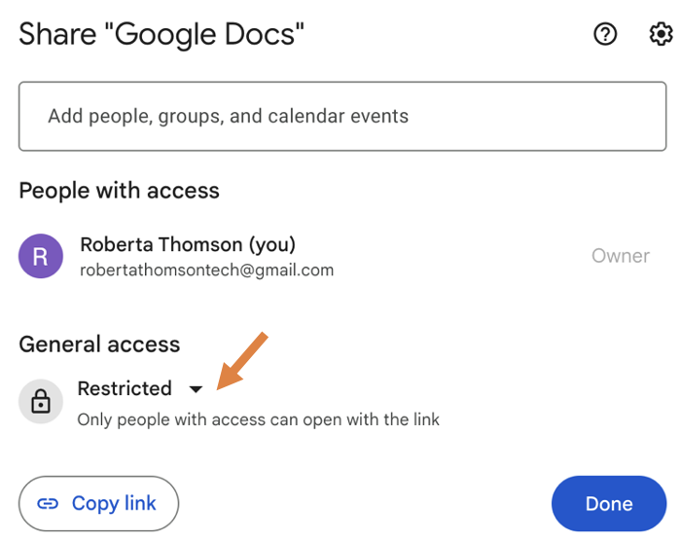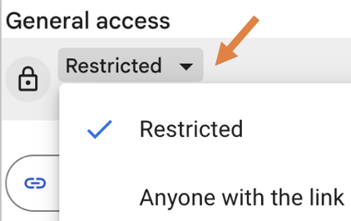

- To add people, type the person(s) email address and select the permission you want to grant (Viewer, Commenter or Editor). Check if you
want to notify them by email that they now have access and add any message. Click on the Copy Link symbol for a link to this Doc.
When done, click Send. In this example, when you go back into the Share section the person assigned is now set up as an Editor.
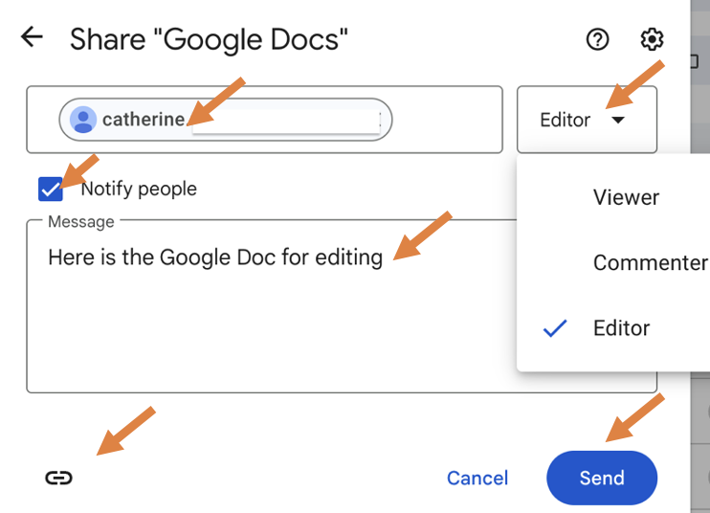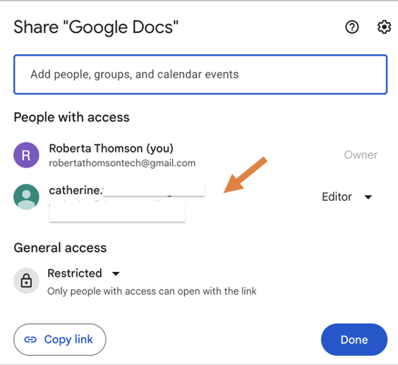

Share a Document to ‘Anyone with the link’:

- You can choose if your file will be available to anyone or restricted to only the people with access. If you allow access to anyone with the link, your folder won't restrict who can access it. Select from three options for the Role anyone with the link can have: Viewer, Commenter or Editor.
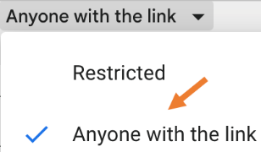
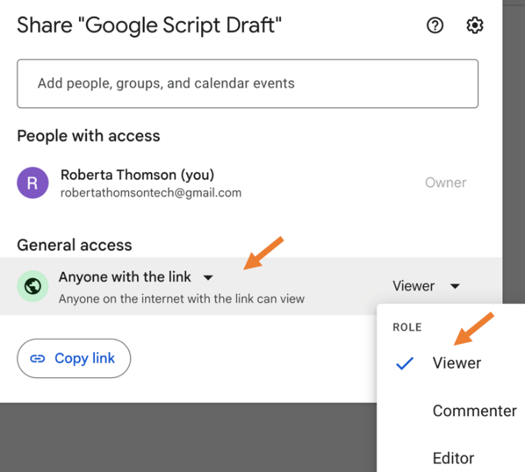

- Click on ‘Copy Link’ to obtain a Shareable link, then click Done.

Share your Document from within the Doc itself:

- When in a Google Doc, locate the Share button near the top right. Click on the word ‘Share’ and it takes you to the same sequence to determine who will have access to the Doc, the type of access and the Role. These are shown in the steps mentioned earlier in the video.

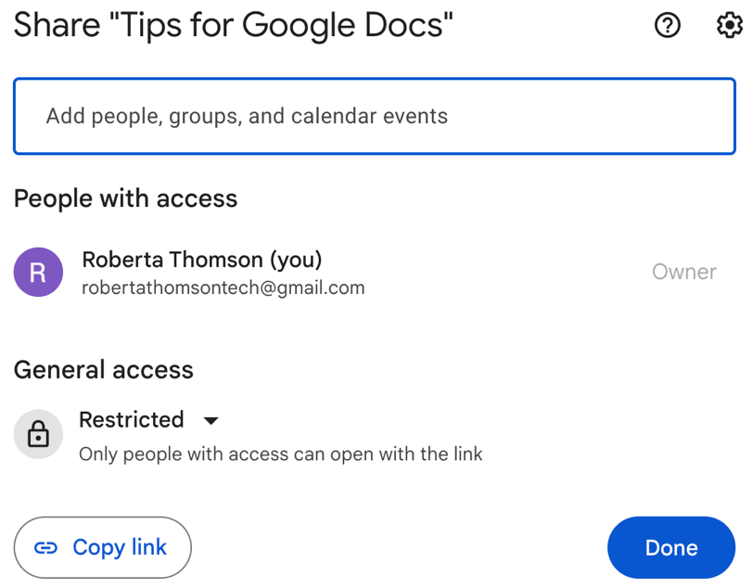

- If you click on the down arrow beside Share, you have the option to ‘Copy Link’ and you will see any previous actions for this Doc. In this
case it has been ‘Shared with 1 person’.
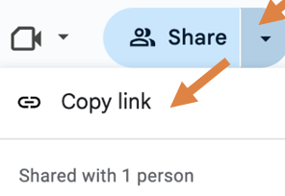

- As a user, if you have a link to a Doc and are not signed into Google and need access, click on the note ‘Request Edit access’ and a message
will be sent to the person who owns the Doc. The owner of the Doc can receive an email and will see this request as shown below when
they are in their Doc. To grant access, the owner selects which role to assign this person. There is the option to Notify and send them
message if you choose. Then click ‘Share’.
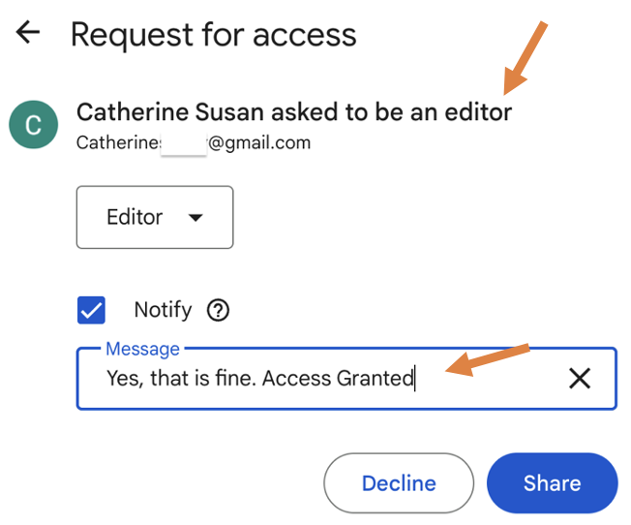

Determining who is viewing, commenting, or editing a Google Doc:

If a person is in a shared Doc in any role (Viewer, Commenter, Editor) and using a shared link but not signed into a Google Drive or Gmail their
presence will show up as an Anonymous animal icon.

When a person is accessing a shared Doc and is signed into their Google Drive and Gmail in any role (Viewer, Commenter, Editor) their initial(s)
will show near the top right.

Viewing the History of a Google Doc:

- The history of all changes made in a Doc is kept. This can be accessed through the ‘clock’ icon on the top right area of the toolbar between
‘Show Chat’ and ‘Show all Comments’. By hovering over the clock this will show the time of the ‘Last edit’.

- Click on the ‘clock’ to see ‘Version history’ of the Doc. Click on the three vertical dots, it will give the options to Name this version or make a
copy.
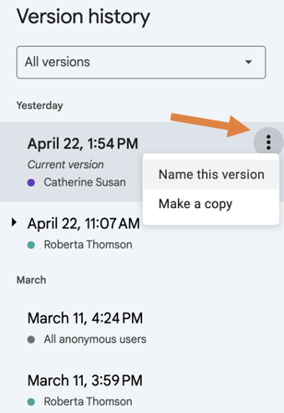

- When you click on any date in the version history you will be shown a version of the Doc at that time before any subsequent changes. You
Will have the option to ‘Restore this version’ which is found near the top left of the screen.

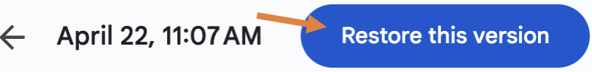

Viewing Edits to a version of a Google Doc:

- To see what edits have been done to a Doc, click a date in the Version history. This opens the Doc for that date and time, and you can see the number of edits. The edits are shown in a different colored font and are highlighted.
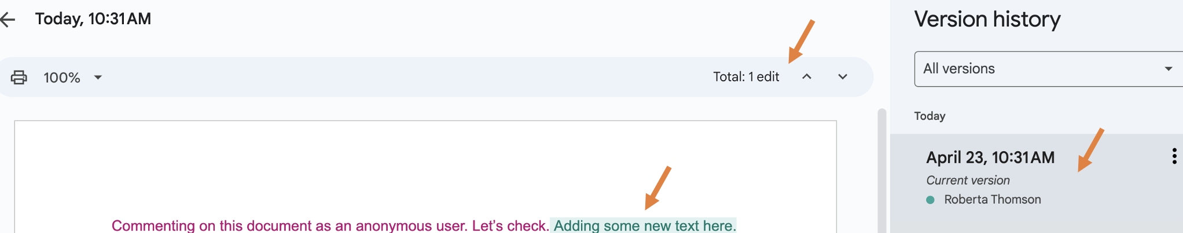

Thank you for viewing this short video on Google Doc permissions for sharing, making changes anonymously, viewing the version history for the Doc
and restoring changes.

Roberta Thomson, Adaptech Research Network
Funding: Entente Canada-Québec (ECQ)

