How to use Live Captions and Transcripts in Teams
Welcome to this short video on how to make Microsoft Teams accessible to a diversity of users using live captions and transcripts. This is available in the New Teams for Schools and Students. Personal Teams accounts permits captions but not transcripts.
Live Captions: Teams detects what is spoken in a meeting and presents real-time captions of this.

- Prior to a meeting, Open Teams in the desktop App or web-based Teams. Go to Settings by clicking on the three dots “…” at the top right of the screen beside your organization and photo or initials. This will open a box where you can click on Settings.
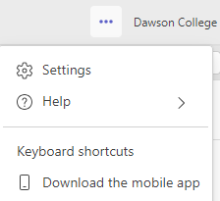
- On the left of the screen under Settings find ‘Captions and transcripts.’ Then on the right you will see several options: Automatically be identified as yourself in meeting captions and transcripts, Filter profane words in meeting captions and to Always show live captions in meetings. It is suggested to leave ‘Always show live captions in meetings’ turned off at this point. They can be turned on individually within the Teams meeting. Instructions for this are shown in Step 3.
Note: Teams doesn’t save captions. To get a transcript of captions download it after the meeting. Instructions are shown later in this video.
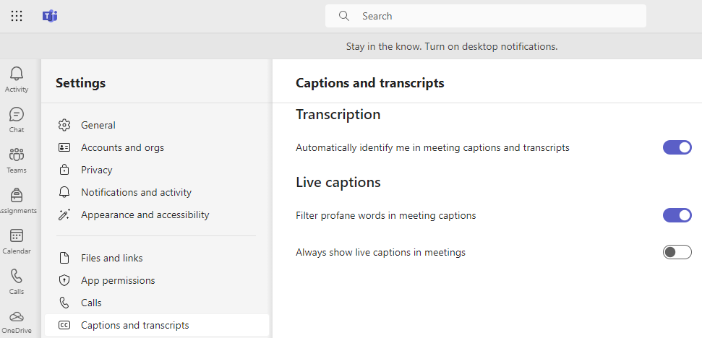

Now you are ready to go into a live Teams meeting. Go to your Calendar located in the left column below Assignments.
Get into a live meeting by joining a meeting already set up in your calendar, or # Join with an ID or Meet Now.

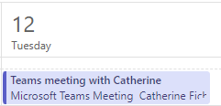

- Once in the Teams meeting you can turn on live captions. Click on the three dots ‘…’ above ‘More’ near the top right of your screen between Apps and Camera. A dialogue box will open. Click on ‘Language and speech’ then click on ‘Turn on live captions.’ Captions will then start to appear according to your Caption settings.
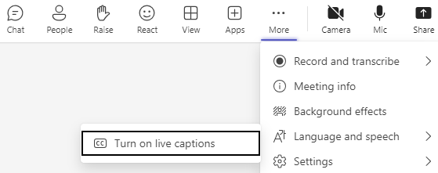

- The appearance of Captions on your screen will show according to your Settings within the Teams Meeting. As shown here they appear at the bottom of the Teams screen, with a black font on a white background.
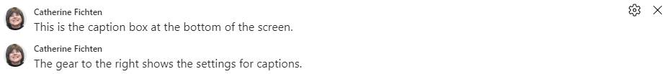
To adjust the appearance, click on the gear at the top right of the caption box. This will open the Caption settings 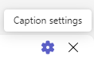
where you can customize how you want the captions to appear in the meeting. You can confirm or select the spoken language and see a
sample of what your captions will look like. Then you can customize the font colors, background colors, the height of the caption box, the
position at the top or bottom of the Teams screen and set the font size.

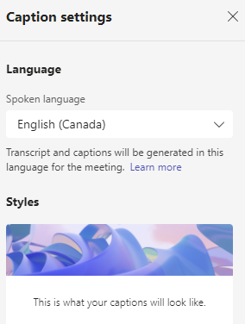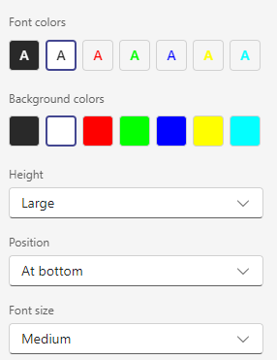

Transcripts
- Start a Transcript by turning it on in a live meeting. Go to , click on ‘Record and transcribe’ then select ‘Start transcription’.
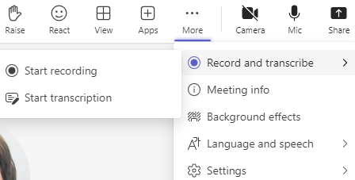
Next, select the language everyone is speaking. When done a text box lets you know the transcription has started and a column on the right shows that the Transcript has started and will show the text of what is being spoken as the meeting goes along.

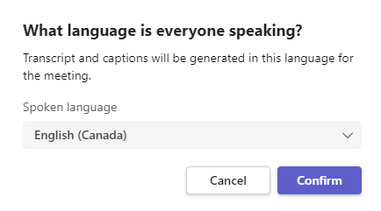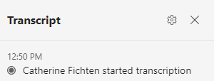

By clicking on the gear in the Transcript box you can select and confirm the spoken language.

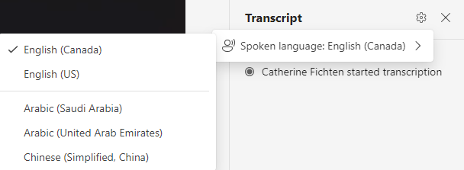
- When done creating a Transcript, go to , select ‘Record and transcribe’ and then select ‘Stop transcript’. A text box lets you know the transcription has stopped and it’s also shown in the column to the right. You also have the option to ‘Hide transcript’.

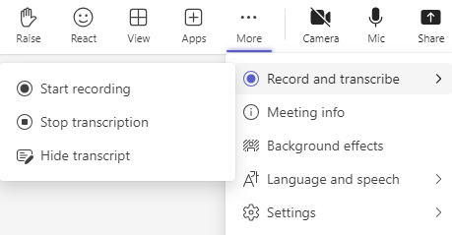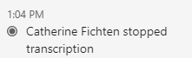

- Once the Teams meeting is finished, you can locate the Transcript by clicking on the Chat area on the left your Teams Home page. This will open the Chat area for all your meetings. Select the meeting you want and click on Chat in the horizontal bar that states “Meet with person x” to show the details for that meeting then click on Transcript.
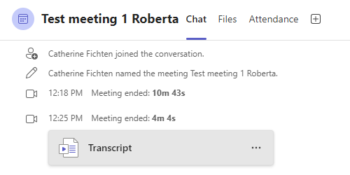

- Once the Transcript is open it will show all spoken text while Transcipt was turned on during the meeting with a timestamp of when it started and when it stopped. You can Download the Transcript by clicking on the down arrow to the right of ‘Download’ which opens a dialogue box for this.
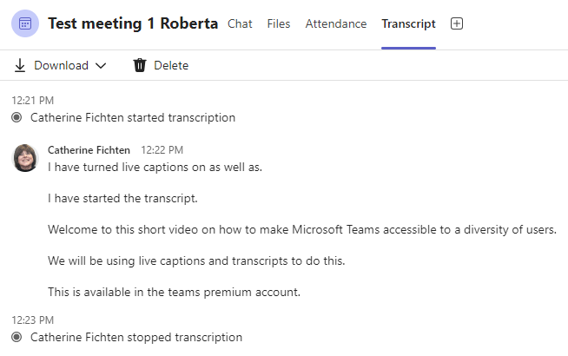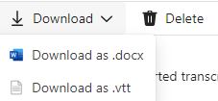

Thank you for viewing this short video on using live captions and transcripts in Microsoft Teams.

Roberta Thomson, Adaptech Research Network
Funding: Entente Canada-Québec (ECQ)

